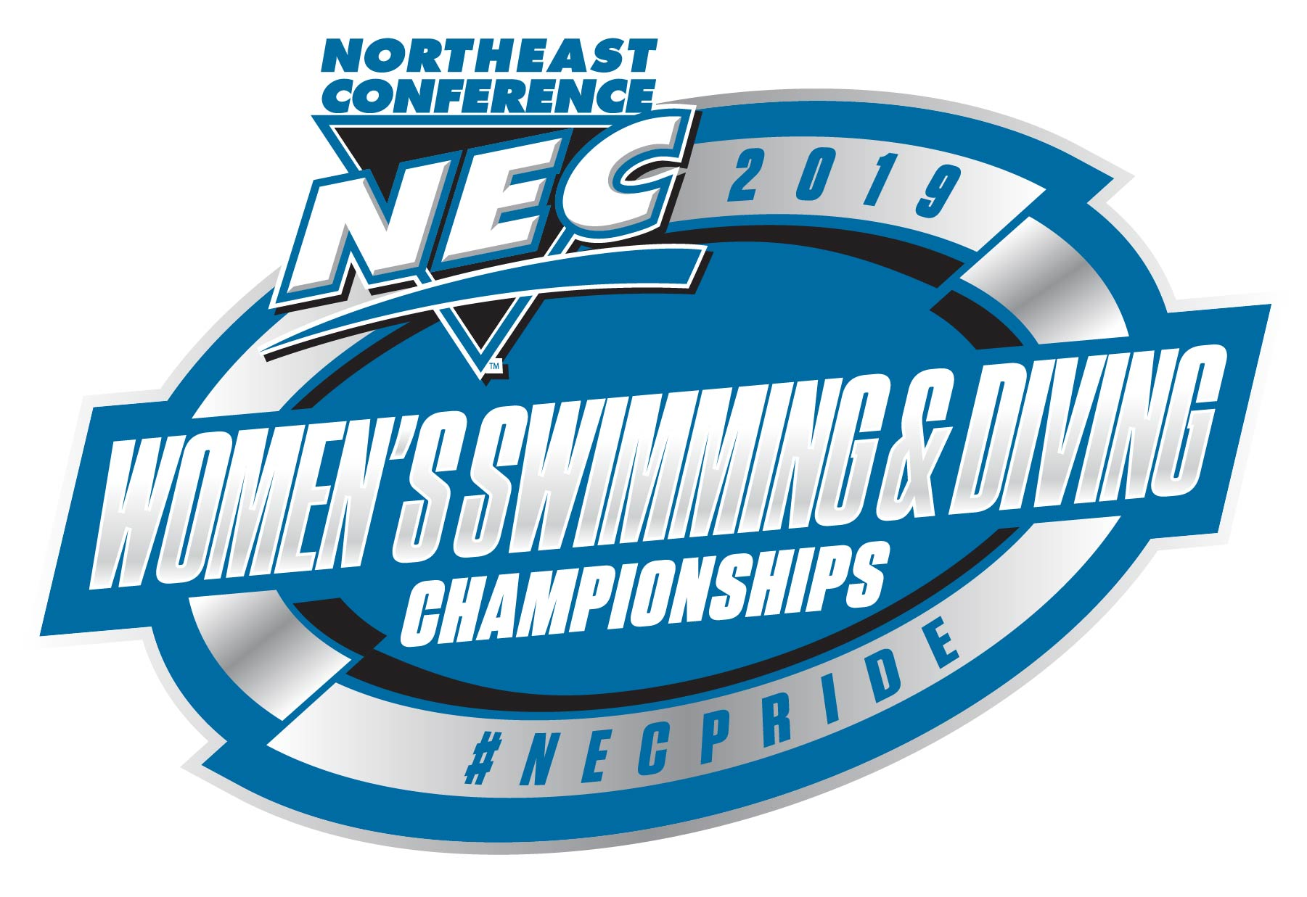

2019, Official Travel Party / Credentials List

School _____________________________

Name

1. _______________________________13. ___________________________25.________________________

2. _______________________________14. ___________________________26.________________________

3. _______________________________15. ___________________________27.________________________

4. _______________________________16. ___________________________28.________________________

5. _______________________________17. ___________________________29.________________________

6. _______________________________18. ___________________________30.________________________

7. _______________________________19. ___________________________31.________________________

8. _______________________________20. ___________________________32.________________________

9. _______________________________21. ___________________________33.________________________

10. ______________________________22. ___________________________34.________________________

11. ______________________________23. ___________________________35.________________________

12. ______________________________24. ___________________________36.________________________

Please indicate:
(P) for player/swimmer/competitor; (C) for coach; (S) for support staff; (A) for administrator
(SR) for graduating senior Note: Administrative passes for each school will be limited to six.

Please email to the NEC’s Benjamin Shove, bshove@northeastconference.org
by Tues. Feb. 5 around Noon.

2019, List of Senior Swimmers & Divers
(to be recognized Sat. night before Finals)

School: ________________________________

1._________________________________________________________

2._________________________________________________________

3._________________________________________________________

4._________________________________________________________

5._________________________________________________________

6._________________________________________________________

7._________________________________________________________

8._________________________________________________________

9._________________________________________________________

10.________________________________________________________

11.________________________________________________________

12.________________________________________________________

Please email to the NEC’s Benjamin Shove, bshove@northeastconference.org
by Tues. Feb. 5 around Noon.

Swimming & Diving
2019, Hotel Contact Information Form

School ________________________________

Name of Hotel Staying at for NEC Championship: _____________________________________

City/Town: _____________________________________

Coach’s Cell Phone Number: __________________________

Sport Administrator & Sport Admin. Cell Phone: __________________________

Please email to the NEC’s Benjamin Shove, bshove@northeastconference.org
by Tues. Feb. 5 around Noon.

